ALIGN

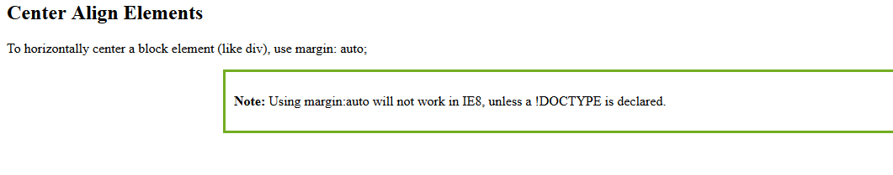

<!DOCTYPE html>

<html>

<head>

<style>

.center {

margin: auto;

width: 60%;

border: 3px solid #73AD21;

padding: 10px;

}

</style>

</head>

<body>

<h2>Center Align Elements</h2>

<p>To horizontally center a block element (like div), use margin: auto;</p>

<div class="center">

<p><b>Note: </b>Using margin:auto will not work in IE8, unless a !DOCTYPE is declared.</p>

</div>

</body>

</html>